CSE18R272-LAB MANUAL

KALASALINGAM ACADEMY OF RESEARCH AND EDUCATION

COMPUTER SCIENCE AND EDUCATION

Date : 23-10-2020

Name :. G.Mohan Gopi Krishna

Regno : 9919004081

Course Name : Java Programming

Course Code : CSE18R272

Section : A5

**EXERCISE—6**

1. **Write a program that creates a user interface to perform integer divisions. The user enters two numbers Num1 and Num2. If Num1 or Num2 is not an integer, the program would throw Number Format Exception. If Num2 is Zero, the program would throw an ArithmeticException. Display the exception.**

SOURCE CODE:

import java.io.*;

public class Main{

public static void main(String[] args) throws IOException {

String num1,num2;

int n1,n2,d;

BufferedReader br=new BufferedReader(new InputStreamReader(System.in));

try{

num1=br.readLine();

num2=br.readLine();

n1=Integer.parseInt(num1);

n2=Integer.parseInt(num2);

d=n1/n2;

}

catch(NumberFormatException e)

{

System.out.println("Sorry Invalid input !!");

}

catch(ArithmeticException ae)

{

System.out.println("Divide by zero error");

}

}

}

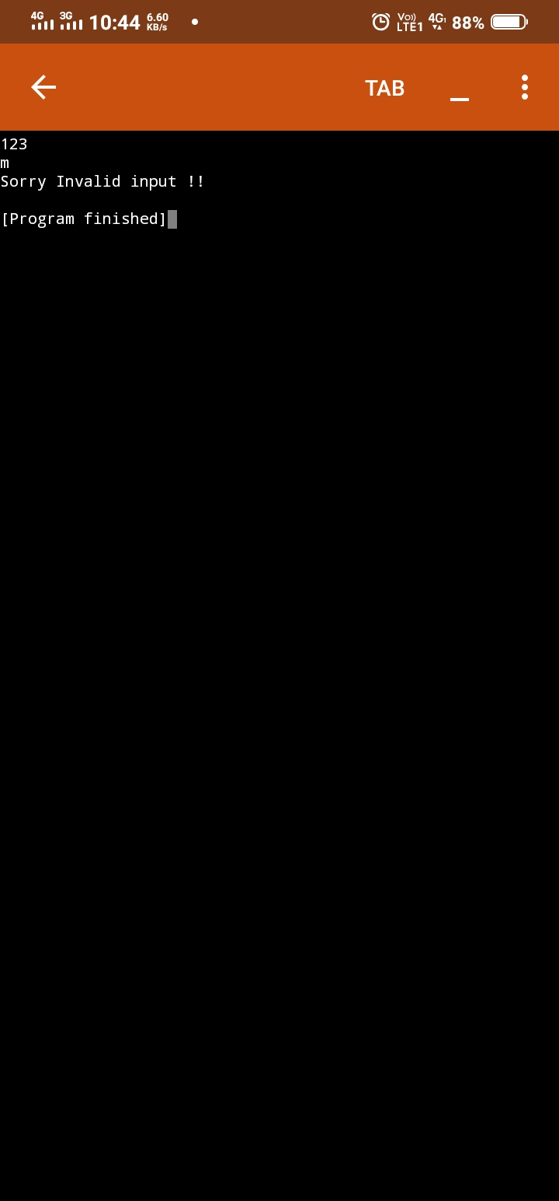

**2. Java programs to create an bank account with minimum balance, deposit amount,withdraw amount and throwsLessBalanceException, create a LessBalanceException class which returns a statement says withdraw amount is not valid, creates2 accounts and try to withdraw more money than account and see which type of exception occurs.**

SOURCE CODE:

import java.io.*;

class BalanceCheck extends Exception{

BalanceCheck(){

super("Sorry your Transaction Denied due No minimum balance found....!!");

}

}

class Bank{

int accountno;

String name;

double balance;

static int min_amount=500;

Bank(int ano,String nm,double bal,int min){

accountno=ano;

name=nm;

balance=bal;

}

void Withdraw(double cash) throws BalanceCheck{

if((balance-cash)>=min_amount){

balance=balance-cash;

System.out.println("Transaction Succesful");

System.out.println("the balance after withdrawl is "+ balance);

}

else{

throw new BalanceCheck();

}

}

void Deposit(double cash){

balance = balance+cash;

System.out.println("Transaction Succesful");

System.out.println("the balance after deposit is "+balance);

}

void CheckBal(){

System.out.println("the balance is"+balance);

}

}

public class Main

{

public static void main(String[] args) throws Exception {

Bank b1 = new Bank(4081,"Gopi",50000,2000);

Bank b2 = new Bank(4095,"Sai Krishna",8000,900);

try{

b1.Withdraw(4800);

b2.Withdraw(68000);

}

catch(BalanceCheck b){

System.out.println(b);

}

b1.CheckBal();

b2.CheckBal();

b1.Deposit(2000);

b2.Deposit(4000);

b1.CheckBal();

b2.CheckBal();

}

}

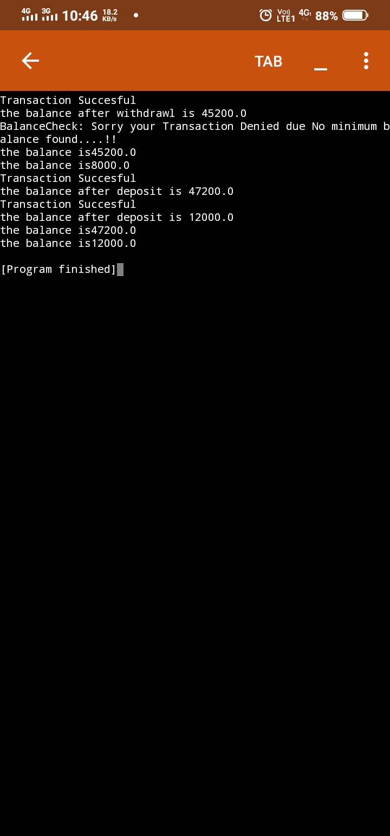

**3. Write a Java program to check whether the age entered is a valid number by creating user defined exception.**

SOURCE CODE:

import java.util.*;

class AgeCheck extends Exception

{

AgeCheck()

{

super("invalid age ");

}

}

public class MyClass {

public static void main(String args[]){

int age;

Scanner s=new Scanner (System.in);

age=s.nextInt();

boolean b=false;

try

{

b=checkAge(age);

System.out.println("valid age");

}

catch(AgeCheck ag)

{

System.out.println(ag);

}

}

static boolean checkAge(int age)throws AgeCheck

{

if(age >0 && age <=120)

return true;

else

throw new AgeCheck();

}

}

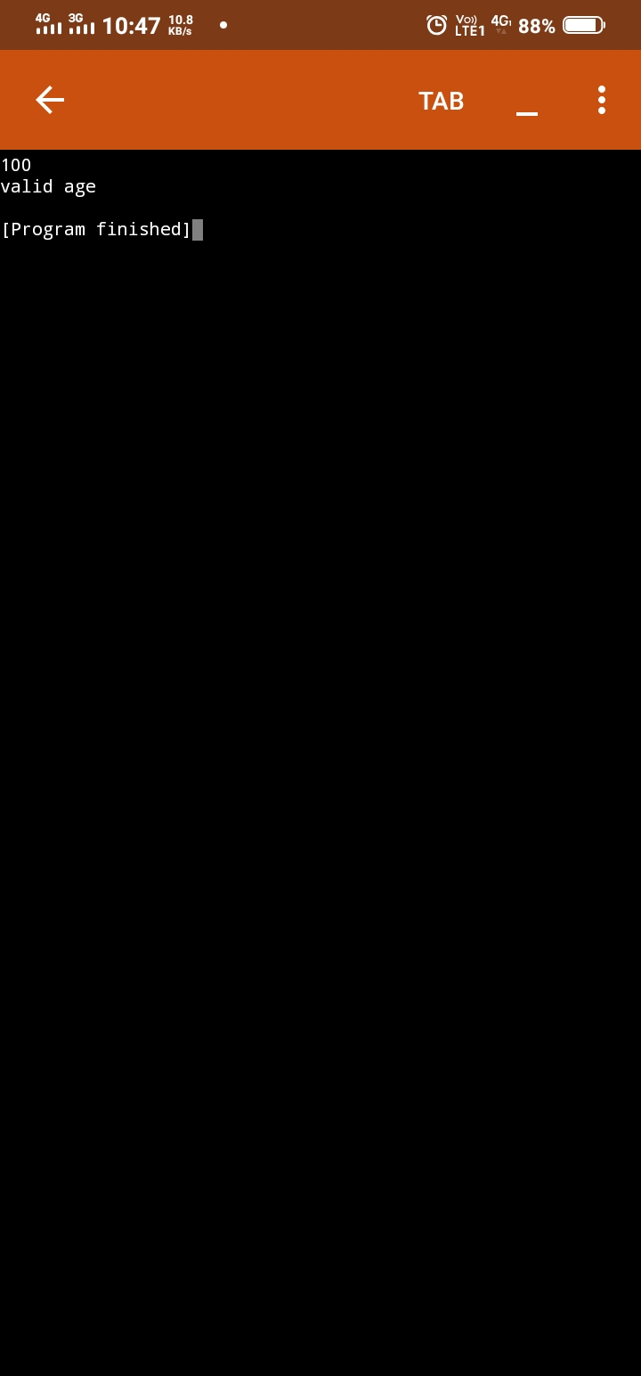

**4. Design a Java interface for ADT Stack. Implement this interface using array.Provide necessary exception handling in both the implementations.**

SOURCE CODE:

class FullStack extends Exception

{

FullStack()

{

super("Stack is Full");

}

}

class EmptyStack extends Exception

{

EmptyStack()

{

super("Stack is Empty ");

}

}

class Stack

{

int top;

int arr[];

static int max=10;

Stack()

{

top=-1;

arr=new int[max];

}

void push(int x)throws FullStack

{

if(top==max-1)

{

throw new FullStack();

}

else

{

arr[++top]=x;

}

}

int pop()throws EmptyStack

{

if(top==-1)

{

throw new EmptyStack();

}

else

{

return(arr[top--]);

}

}

void print()

{

for(int i=0;i<arr.length;i++)

System.out.print(arr[i]+" ");

System.out.println();

}

}

public class MyClass {

public static void main(String args[]) {

Stack s1=new Stack();int x;

for(int i=1;i<=12;i++)

{

try{

s1.push(i);

s1.print();

}

catch(FullStack fs)

{

System.out.println(fs);

}

}

for (int i=1;i<=12;i++)

{

try

{

x=s1.pop();

System.out.print(x +" ");

}

catch(EmptyStack es)

{

System.out.println(es);

}

}

}

}

